University of Essex Online

Module: Machine Learning April 2026
Assignment: Development Team Project: Project Report
GROUP D

Word count: 1096
Submission Date: 07/06/2026

Table of Contents
1. Objective 4
2. Methodology 4
3. Limitations 5
4. Results and analysis 5
4.1 Initial market insights 5
4.2 Regression: price prediction and main price signals 6
4.3 Market segmentation 7
5. Business recommendations 9
5.1 Differentiation 9
5.2 Recommendations per segment 9
5.3 SWOT for zero availability 9
5.4 Market protection 9
6. References 11
7. Appendix 14

List of Figures
Figure 1: borough group contrast 6
Figure 2: listing room-type and log_price 8
Figure 3: Silhouette quality by listing segment 15

List of Tables
Table 1: Regression price model comparison 6
Table 2: Pricing signals evaluation 7
Table 3: K-means listing segments 8
Table 4: Largest absolute coefficients from Model 2 14

- Objective
This report shares the application of regression and clustering on the “Airbnb-NYC-2019” (Dgomonov, 2019) dataset to answer: “Can Airbnb identify pricing patterns and listing segments in the NYC market to support hosts with competitive pricing and segment guidance?”
- Methodology
CRISP-DM links the machine-learning workflow with the business question, allowing loop-back for adjustment (Chapman et al., 2000; Schröer, Kruse and Gómez, 2021). EDA, data cleaning and feature preparation made the dataset suitable for modelling; handling of missing, zero, no-review and extremes values that induced distortion. Price was transformed into log_price because log transformation is widely used for skewed variables, categorical variables were encoded, and clustering inputs were standardised because regression and distance-based clustering require suitable numerical inputs, and K-Means is sensitive to scaling (Bishop, 2006; James et al., 2023).
For pricing prediction, three regression models were compared in a nested progression from simple to complex, following Bishop (2006) and James et al. (2023) model-comparison guidance with predictors that improve performance while retaining interpretation. Therefore, the model used observable listing signals. Categorical attributes were encoded into yes/no columns usable for regression.
Model 1 used room-type dummy variables as baseline. Model 2 added nine selected features. Model 3 added degree-2 polynomial terms to test whether limited extra complexity improves practical prediction. An 80/20 hold-out split was used with R² and RMSE compared on the 20% test set using log_price as target.
Bishop (2006) presents K-Means as an unsupervised method that groups observations around cluster centers on a distance-based objective, and the scikit-learn K-Means documentation also describes the method through inertia and within-cluster sum of squares (Pedregosa et al., 2011; scikit-learn, no date). Therefore, K-Means was used on scaled listing features to prevent scale distortions. K values from 2 to 6 were tested using elbow/SSE and silhouette logic (Rousseeuw, 1987; Thinsungnoen et al., 2015), with 3 selected as the practical grouping based on the outcome and business interpretation linkage. Inputs and diagnostics are in Appendix.
- Limitations
The dataset is a snapshot and lacks customer data, such as guests or bookings. Availability exists, but it does not provide reason; therefore, it is treated as a cautious listing signal rather than a customer-demand proxy; as a consequence, direct customer segmentation is not possible.
Airbnb (2023) emphasizes the extended listing attributes that impacts pricing-guidance, and Ert, Fleischer, and Magen (2016) that photos influence trust in Airbnb-style decisions. Features such as photos, facilities, ratings, and seasonality are missing from the dataset. Therefore, the price prediction model is not complete.
Limitations shift segmentation from customer to listing level, and price prediction towards listed-price guidance.
- Results and analysis

4.1 Initial market insights
After cleaning, the dataset has 48.847 listings with strongly skewed prices: median $106, mean $153, and 99th percentile $799 with outliers distorting up the curve.
Manhattan and Brooklyn concentrate 85% of listings, census data shows they account for 50.3% and 30.6% of population and land respectively (United States Census Bureau, nd.)
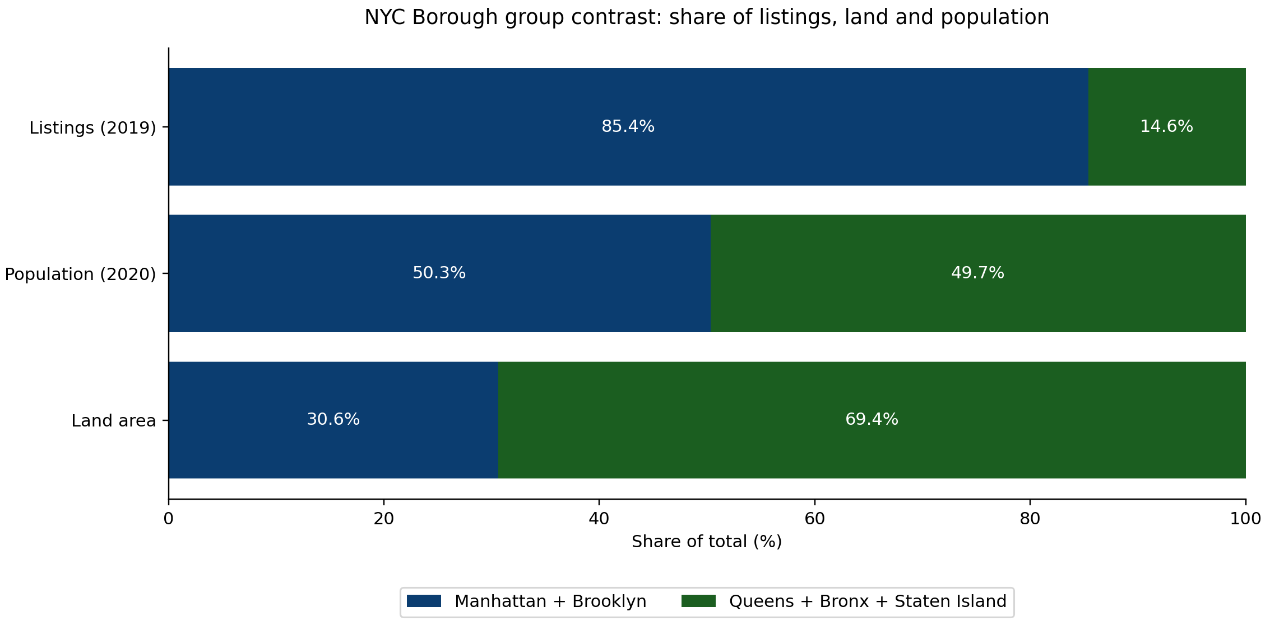
Figure 1: borough group contrast
Availability: 35.8% of listings have zero availability for unknown reasons, this could mean high-demand, or inactivity, thus it is a cautious listing signal, not demand.

4.2 Regression: price prediction and main price signals
Model 3 performs best explaining 54.4% of observed log_price variation. Table 1 shows the model comparison.
Table 1: Regression model comparison
Model | Tested | R² | RMSE | Interpretation
Model 1: Baseline | Room type | 0.3791 | 0.5444 | Explains meaningful variation.
Model 2: Multiple linear | Listing, location, review, availability and host-scale features | 0.4946 | 0.4912 | More features, prediction improves.
Model 3: Polynomial degree 2 | limited complexity on same feature-base | 0.5436 | 0.4667 | Best, explains 54.4% of observed log_price variation.

Table 2 main pricing evidence from EDA and regression:
Table 2: Pricing signals evaluation
Pricing signal | Outcome | Business interpretation
Room type | Strongest tested signal; baseline R² = 0.3791; top two Model 2 coefficients are room-type dummies | First peer comparison should be by room type.
Borough/location | Manhattan + Brooklyn hold 85% of listings | NYC is not one flat market; location matters.
Availability | 35.8% zero availability; feature helps model | Useful signal, but reason is missing.
Reviews / activity | Review variables included as tested features | Activity/reputation context, not bookings.

Room type is treated as the strongest tested price signal because EDA, baseline R² and Model 2 coefficient ranking all support it. James et al. (2023) separate model evidence from causal interpretation, so this remains association, not a causal effect. Coefficient details are in Appendix.

4.3 Market segmentation
The clustering is based on listing segmentation; room type was included as a feature input; therefore, the segment labels are three room-type-led listing groups shown in Table 3:
Table 3: K-means listing segments
Segment | Share | Price | Availability | Borough skew
Entire home | 52.6% | $176 | 113 days/annum | Manhattan-skewed
Private room | 45.1% | $72 | 110 days/annum | Brooklyn-skewed
Shared room | 2.4% | $54 | 162 days/annum | Mixed

Figure 2 clusters visualisation:
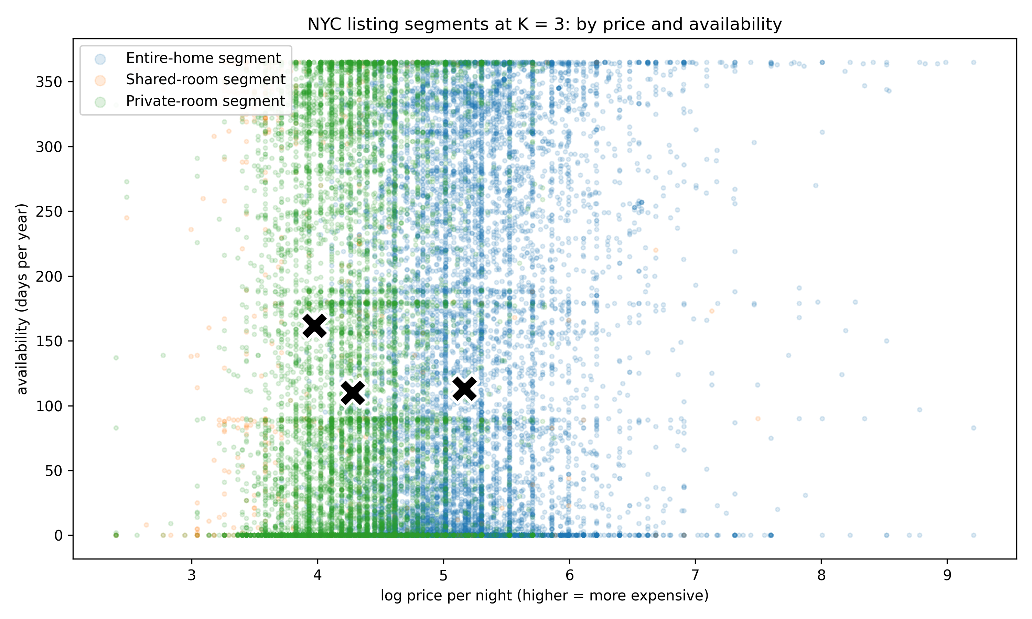
Figure 2: listing room-type and log_price
The X show each segment center; higher log_price means a more expensive listing; the groups are useful for host guidance, but the overlap means they are not fixed boundaries.
- Business recommendations

5.1 Differentiation
Porter (1980) argues that better business outcomes are possible from differentiation and focus rather than generic market-wide treatment. Hosts need visibility where differentiated offers can justify higher prices, thus Airbnb could test Model 3 as a peer-price benchmark based on room type, borough and availability, providing hosts with informed price-position guidance.

5.2 Recommendations per segment
Test a focus strategy by providing segment-specific host recommendations (Porter, 1980). Using the cluster segments, entire-home hosts should receive premium guidance, while private-room hosts should receive value and occupancy guidance, enabling selective price increase through focused differentiation.

5.3 SWOT for zero availability
Weihrich’s (1982) TOWS logic utilises strategy to match opportunities and threats with conditions, and later Helms and Nixon (2010) review SWOT as an academic strategy tool. In this case, the 35.8% of listings with zero availability is both an opportunity and a risk. Airbnb should classify the reason and produce responses, potentially saving costs by removing listings or signaling opportunities to increase prices for fully booked listings.

5.4 Market protection
Manhattan and Brooklyn concentrate 85% of listings, suggesting a crowded red-ocean market, while Queens, the Bronx and Staten Island have lower listing share despite comparable population and more land, making them blue-ocean test area as depicted by Kim and Mauborgne (2005). Airbnb could test room-type peer benchmarks in concentrated areas to protect revenue, while recruiting new hosts in lower-share ones to potentially increase revenue.
In conclusion, dataset limitations hinder more robust price prediction and customer segmentation, however the results provide pricing guidance, listing segmentation, and testing of several initiatives that could lead to better business outcomes.
- References
Airbnb (2023) ‘What is Smart Pricing?’, Airbnb Resource Center, 3 May. Available at: https://www.airbnb.com/resources/hosting-homes/a/what-is-smart-pricing-594 (Accessed: 25 May 2026).

Bishop, C.M. (2006) Pattern Recognition and Machine Learning. New York: Springer. Available at: https://www.microsoft.com/en-us/research/publication/pattern-recognition-machine-learning/ (Accessed: 25 May 2026).

Chapman, P., Clinton, J., Kerber, R., Khabaza, T., Reinartz, T., Shearer, C. and Wirth, R. (2000) CRISP-DM 1.0: Step-by-step Data Mining Guide. CRISP-DM Consortium.

Crawford, S.L. (2006) ‘Correlation and regression’, Circulation, 114(9), pp. 2083–2088. doi:10.1161/CIRCULATIONAHA.105.586495.

Dgomonov (2019) New York City Airbnb Open Data [Dataset]. Kaggle. Available at: https://www.kaggle.com/datasets/dgomonov/new-york-city-airbnb-open-data (Accessed: 9 May 2026).

Ert, E., Fleischer, A. and Magen, N. (2016) ‘Trust and reputation in the sharing economy: The role of personal photos in Airbnb’, Tourism Management, 55, pp. 62–73. doi:10.1016/j.tourman.2016.01.013.

Harmadi, A.C. (2021) ‘10 Things to Do When Conducting Your Exploratory Data Analysis (EDA)’, Medium. Available at: https://medium.com/data-folks-indonesia/10-things-to-do-when-conducting-your-exploratory-data-analysis-eda-7e3b2dfbf812 (Accessed: 25 May 2026).

Helms, M.M. and Nixon, J. (2010) ‘Exploring SWOT analysis – where are we now? A review of academic research from the last decade’, Journal of Strategy and Management, 3(3), pp. 215–251. doi:10.1108/17554251011064837.

James, G., Witten, D., Hastie, T., Tibshirani, R. and Taylor, J. (2023) An Introduction to Statistical Learning with Applications in Python. Cham: Springer.
Kim, W.C. and Mauborgne, R. (2005) Blue Ocean Strategy: How to Create Uncontested Market Space and Make the Competition Irrelevant. Boston, MA: Harvard Business School Press.

Patil, P. (2018) ‘What is Exploratory Data Analysis?’, Medium. Available at: https://medium.com/data-science/exploratory-data-analysis-8fc1cb20fd15 (Accessed: 25 May 2026).

Porter, M.E. (1980) Competitive Strategy: Techniques for Analyzing Industries and Competitors. New York: Free Press.

Rousseeuw, P.J. (1987) ‘Silhouettes: A graphical aid to the interpretation and validation of cluster analysis’, Journal of Computational and Applied Mathematics, 20, pp. 53–65. doi:10.1016/0377-0427(87)90125-7.

Schröer, C., Kruse, F. and Gómez, J.M. (2021) ‘A systematic literature review on applying CRISP-DM process model’, Procedia Computer Science, 181, pp. 526–534. doi:10.1016/j.procs.2021.01.199.

Thinsungnoen, T., Kaoungku, N., Durongdumronchai, P., Kerdprasop, K. and Kerdprasop, N. (2015) ‘The clustering validity with silhouette and sum of squared errors’, Proceedings of the 3rd International Conference on Industrial Application Engineering (ICIAE 2015), pp. 44–51. Available at: https://www2.iaengineers.org/conference/index.php/iciae/iciae2015/paper/view/576 (Accessed: 25 May 2026).

United States Census Bureau (n.d.) U.S. Census Bureau QuickFacts: New York City, New York. Available at: https://www.census.gov/quickfacts/fact/table/newyorkcitynewyork/PST045224 (Accessed: 28 May 2026).

Weihrich, H. (1982) ‘The TOWS Matrix – A tool for situational analysis’, Long Range Planning, 15(2), pp. 54–66. doi:10.1016/0024-6301(82)90120-0.

- Appendix
Pricing signal design
First model, baseline, room-type dummy variables; second model with selected nine features, the same room-type dummies with neighbourhood-group dummy variables and numeric listing features such as latitude, longitude, minimum_nights, number_of_reviews, reviews_per_month, availability_365 and calculated_host_listings_count; third model, degree 2 polynomial terms on the same feature base. Degree 2 was used to test simple curved patterns and feature-pair effects without moving into more complex models that are harder connect with business indicators and analysis.
Table 4: Largest absolute coefficients from Model 2
Rank | Signal from Model 2 | Coefficient
1 | room_type_Private room | -0.3795
2 | room_type_Shared room | -0.1782
3 | longitude | -0.1418
4 | neighbourhood_group_Manhattan | 0.1397
5 | availability_365 | 0.1151

Coefficients are model evidence, not causal effects. Entire home/apt is the room-type reference group, so the negative private-room and shared-room coefficients show lower listed-price position compared with that reference.

K-Means inputs and diagnostics
For clustering, the input features were log_price, minimum_nights, reviews_per_month, availability_365 and room-type dummy columns. The original room_type field was converted into dummy yes/no columns with drop_first=True, so K-Means could use room type without treating it as an ordered number. K values were tested from K = 2 to K = 6 using elbow and silhouette logic (Rousseeuw, 1987; Thinsungnoen et al., 2015). The final groups align mostly with room type, this was expected because room type is part of the clustering input.
Figure 3 assesses the selected K value using listing-level silhouette scores. Positive medians support the three-way split. Nevertheless, some overlap remains, so the segments are used for assistance or guiding but cannot be used as definitive groups (Rousseeuw, 1987).
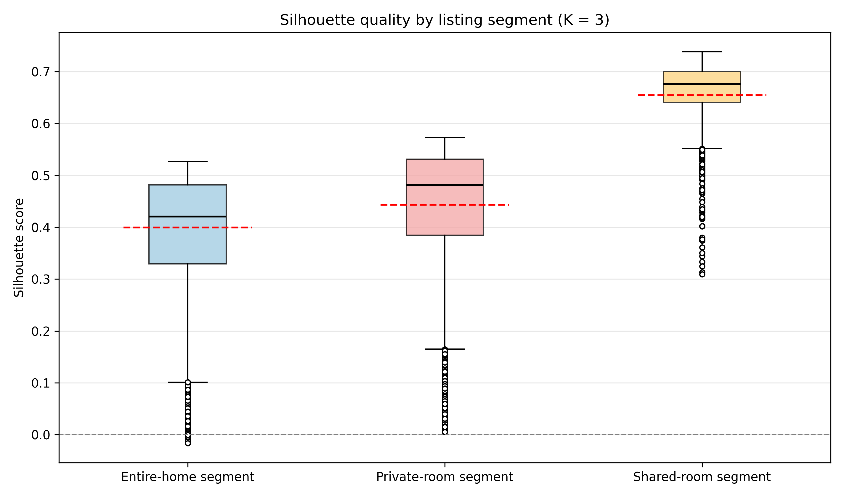
Figure 3: Silhouette quality by listing segment

